**Phage tutorial 3: downstream analyses**

In this tutorial, we will be looking at some of the downstream analysis steps you can perform once you have identified one or more genes/proteins of interest from your annotated genomes. Note that this is by no means an inclusive list (& that you are encouraged to explore the literature/try different data analyses independently), but hopefully this will give you something of a starting point or at least some ideas.

1. **Option 1: BLAST**

You may find this particularly useful for proteins which have been annotated as “hypothetical”, or to find genes/proteins related to your sequence of interest.

Step 1: Navigate to the NCBI blast homepage (<https://blast.ncbi.nlm.nih.gov/Blast.cgi>) and select the type of BLAST analysis best suited to your sequence and task. In this example, I will be using a hypothetical protein sequence from one of my annotated phage genomes. (Remember that you can retrieve the amino acid or nucleotide sequences from your annotated genome using the “Extract sequences from Genbank” tool in Galaxy that we used last time.)

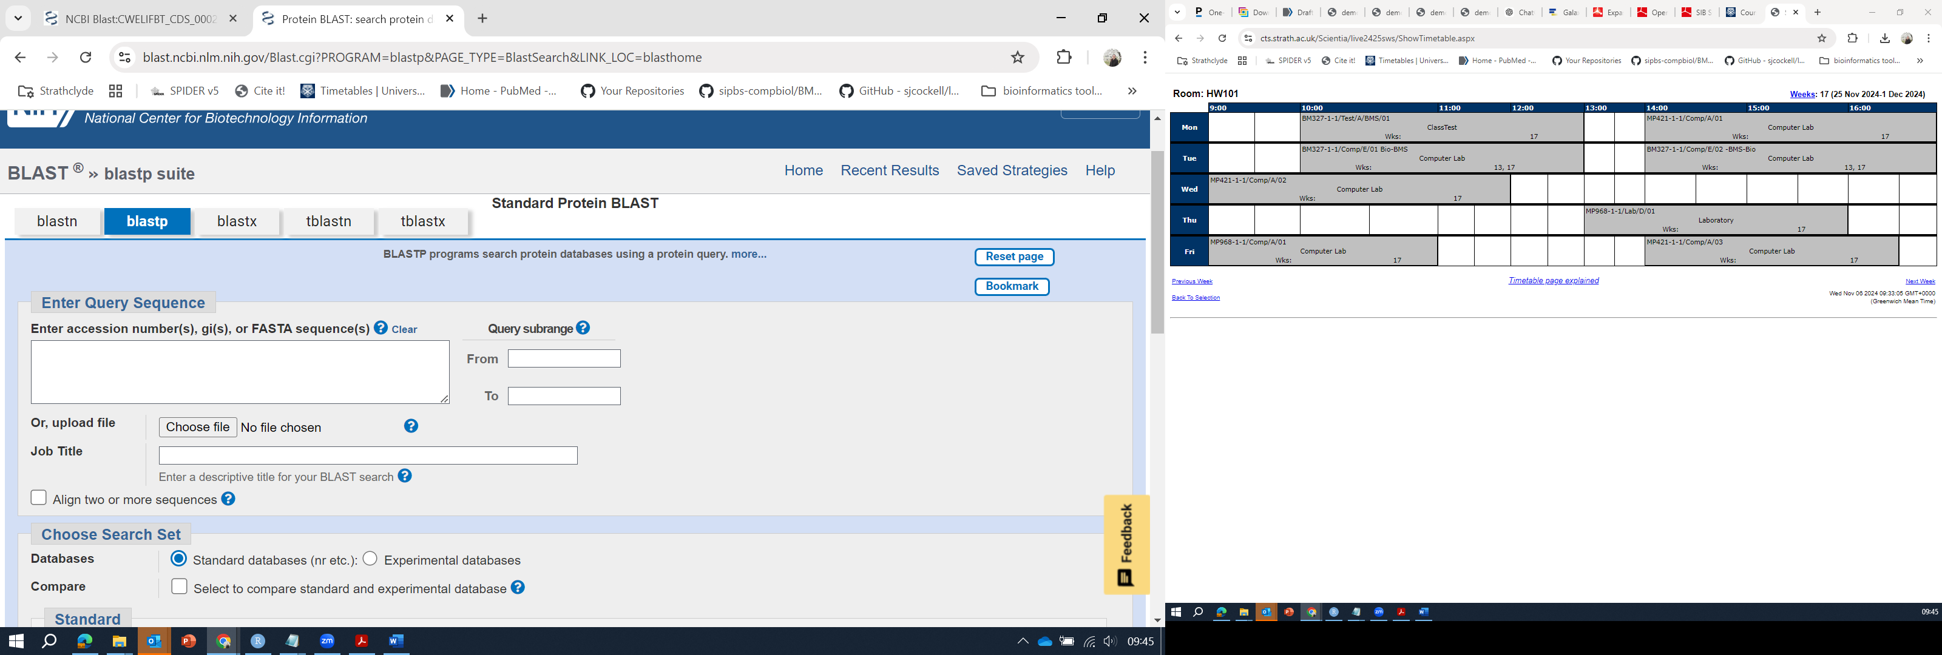

Figure 1. BLASTp search page.

Enter your query sequence (Figure 1) and choose your search set (the database you wish to search). In this example I will be searching for the hypothetical protein annotated as CWELIFBT_CDS_0002 (Figure 2) in the standard nr database, and I am happy to use the default BLASTp algorithm parameters.

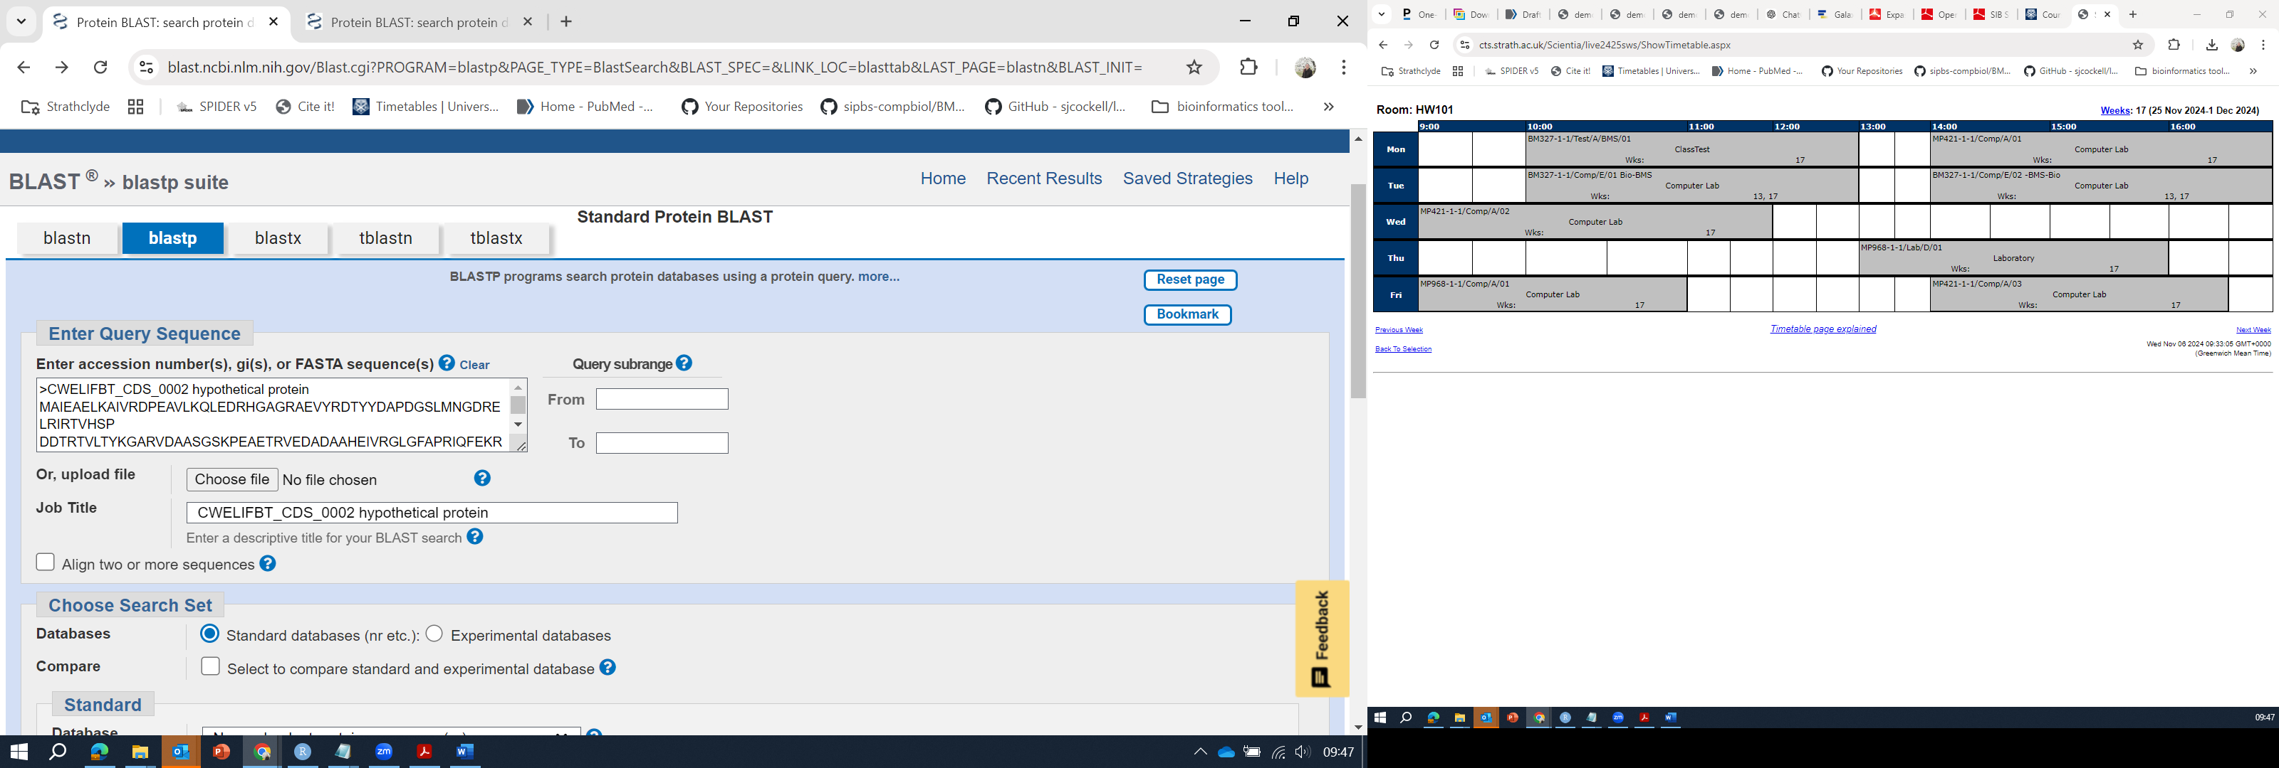

Figure 2. Specifying BLAST query sequence and search parameters.

Hit “BLAST” and wait for the results page to load.

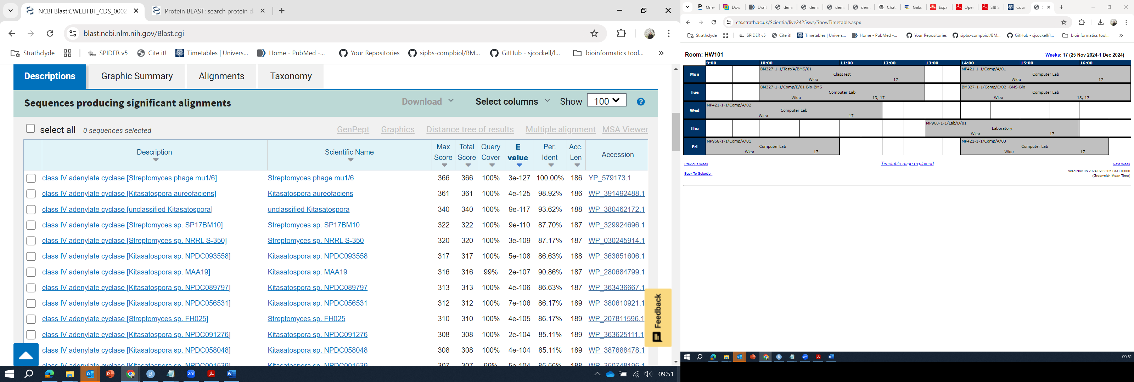

Figure 3. BLAST results (descriptions tab).

Step 2: Analyse and interpret your results

You will want to analyse your results (Figure 3), taking into account the score, query cover, e-value, and percent identity of the hits which match your query sequence.

In this example, it looks like my “hypothetical” protein may in fact be an adenylate cyclase, with homologs present in the genomes of several different *Kitasatospora* and *Streptomyces* spp. (If I wished to better understand how all these proteins are related to one another, I might go on from here to create a phylogenetic tree using these sequences – see the previous tutorial for instructions on creating phylogenetic trees.)

One thing you may wish to note is that you can also certainly create custom BLAST databases (e.g., should you want to search for a sequence of interest in your phage genome(s).

You can do this in Galaxy using the NCBI BLAST+ makeblastdb tool (Figure 4). You will need to specify the type of molecule you are using (protein or nucleotide), and the input sequences. Note that it is usually helpful to choose the option “Parse the sequence identifiers” as “Yes” – this should ensure that your sequences are still associated with their original names.

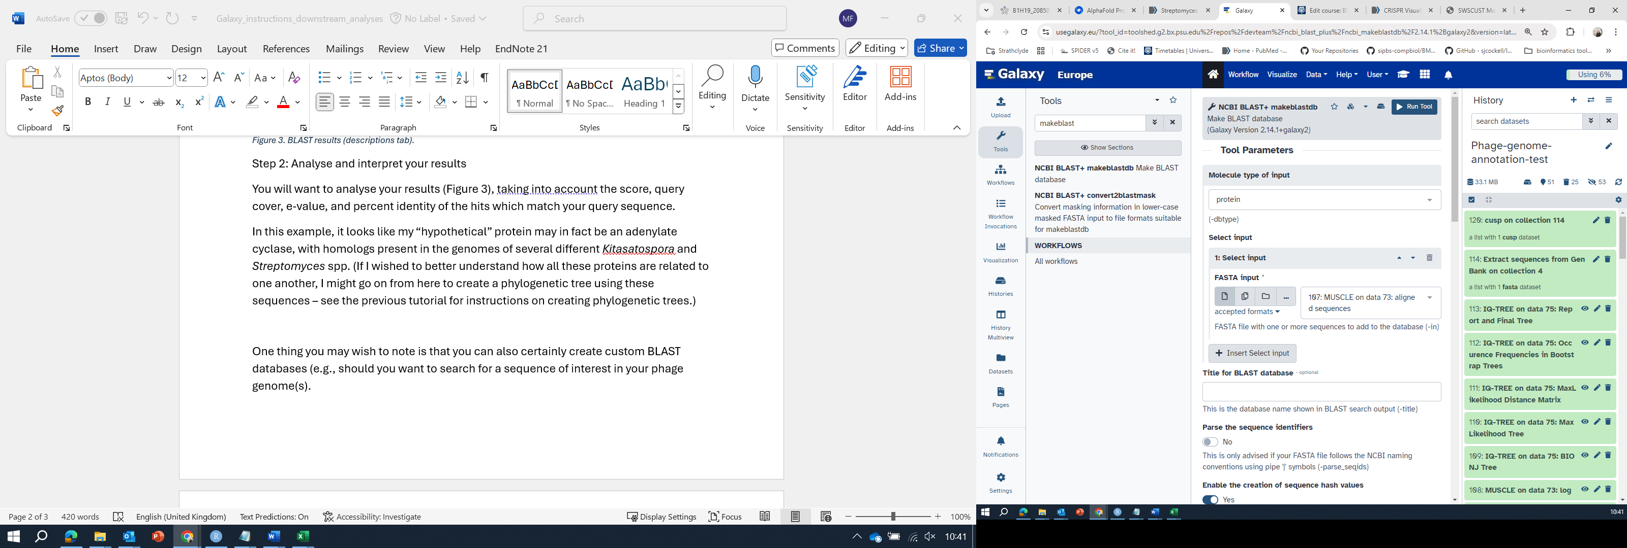

Figure 4. NCBI BLAST+ makeblastdb in Galaxy.

Once you have created a custom BLAST database, you can use the NCBI BLAST+ tools to search it (in this example I created a protein database, and will use BLASTp to search it, but you could also create a nucleotide database and you can use any of the standard BLAST search strategies.)

Here I have made a BLAST database across an entire collection of phage genome sequences (which I had downloaded and annotated in a batch job, collection 64 in my history – and I can now search for my protein of interest (the integrase I’m interested in) across all of these genomes.

When you perform your BLAST search (Figure 5), you will want to specify the BLAST database from your history (in my case, it is the BLAST database I just made, item 122 in my history) and a .fasta file that you wish to use as a query.

You may also wish to change the e-value threshold (this will depend on your gene/protein of interest and must be determined empirically for each sequence).

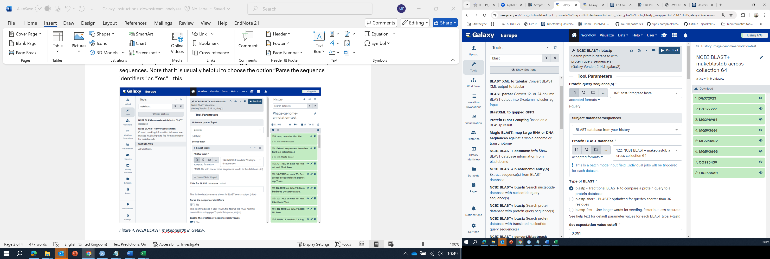

Figure 5. NCBI BLAST+ blastp search of a database from your local history in Galaxy

Note that the standard output format for BLAST searches performed in Galaxy is **tabular** – scroll down the BLAST tool page to see an explanation of the different columns that you will see in your results.

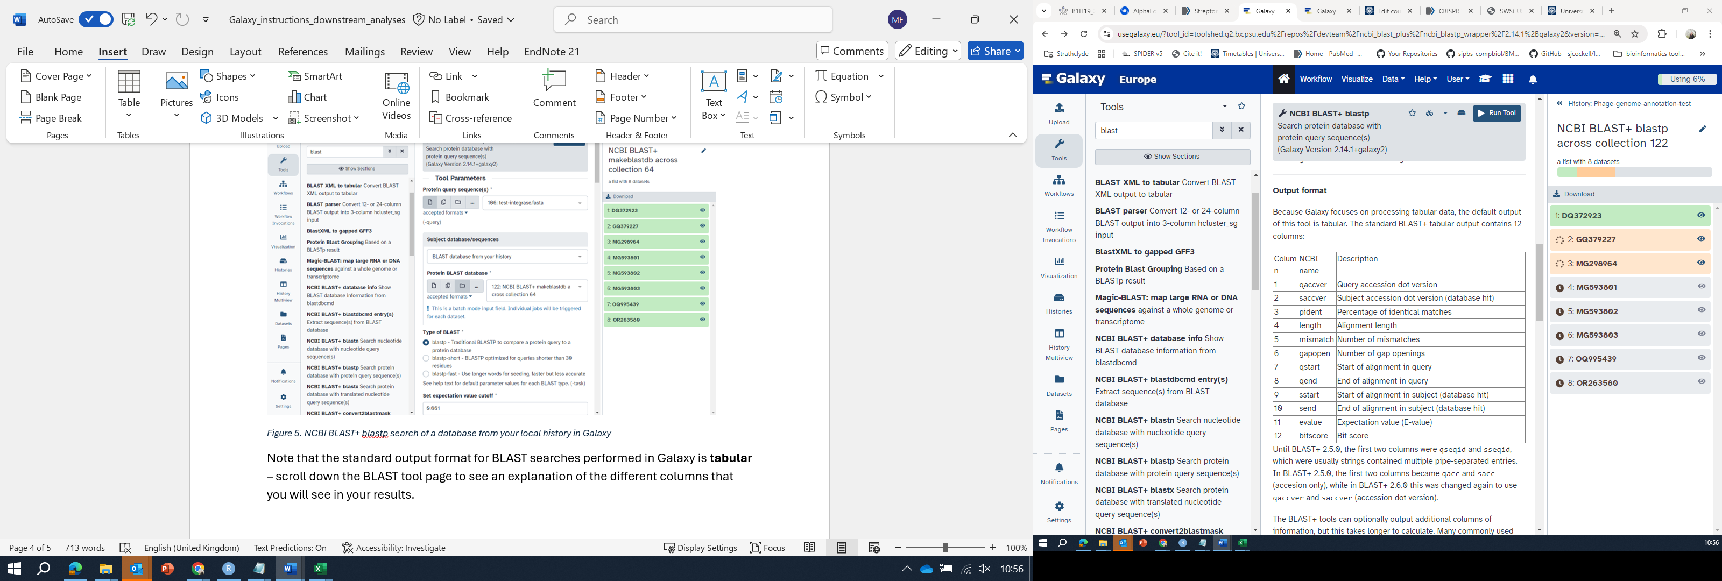

Figure 6. BLAST output format - column descriptions.

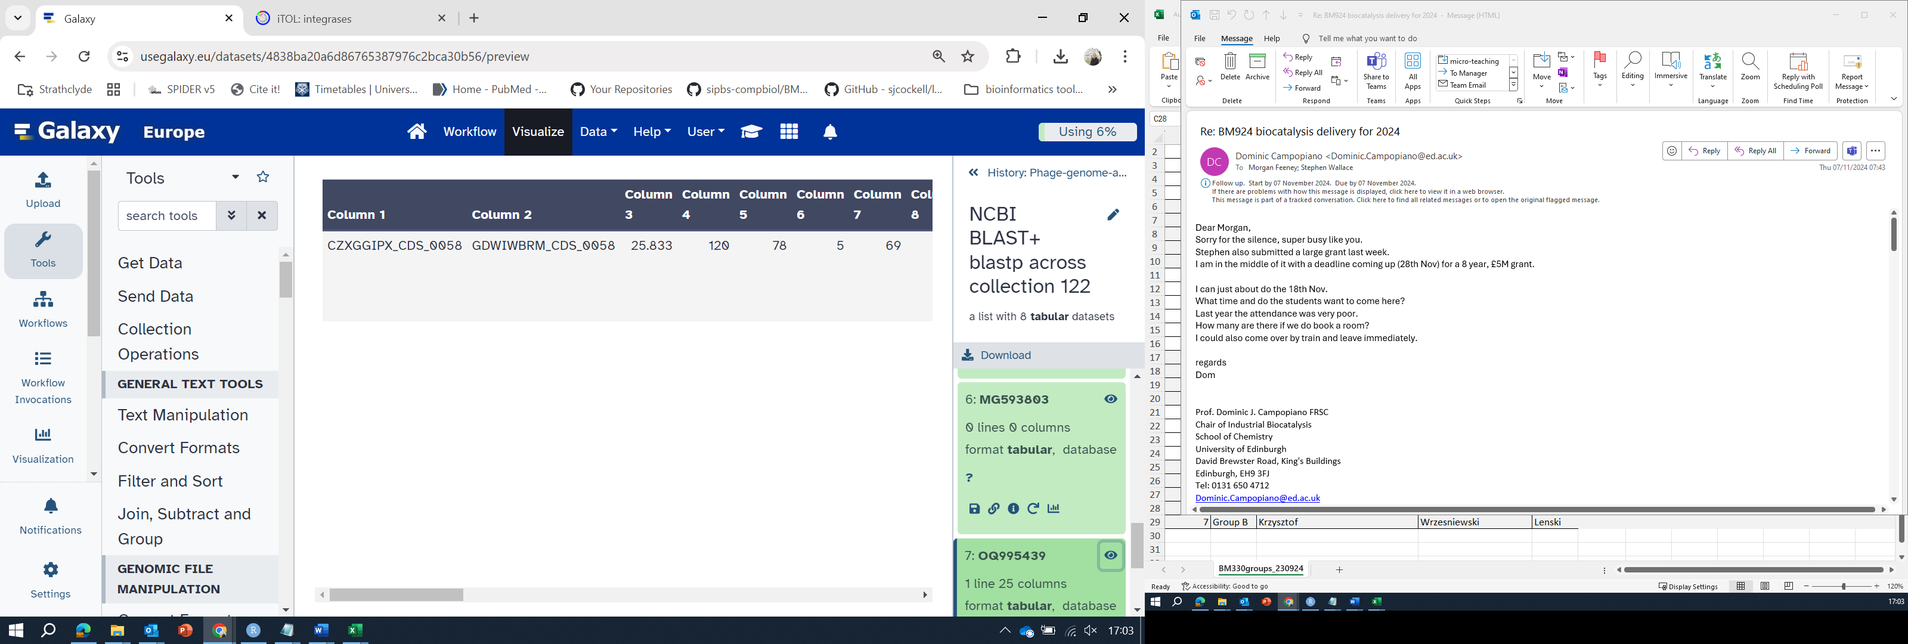

Figure 7. Example of BLASTp results in Galaxy.

Note that when you run a BLAST search across a collection, you will produce a list of results in your history – each corresponding to the BLAST search against that particular BLAST database (Figure 7). In this example we can see that the search against MG593803 produced no hits (0 lines 0 columns), whereas the search against OG995439 produced a hit (to a protein annotated as GDWIWBRM_CDS_0058, which is ~25% identical to the query sequence).

1. **Option 2: Structural analyses of a particular protein**

Depending on your project, you may find it useful/informative to look at the structure, or predicted structure, of a protein of interest.

You can find solved protein structures at the Protein Data Bank (PDB): <https://www.rcsb.org/>

In the event that there is no solved structure for your protein of interest, you may wish to look at AlphaFold predictions: <https://alphafold.ebi.ac.uk/> (bearing in mind that these are predictions only).

You can search this database using a protein’s name or accession number, or with an amino acid search string query (Figure 9). In this example, I am searching for one of the integrase proteins which was annotated in my phage genome of interest.

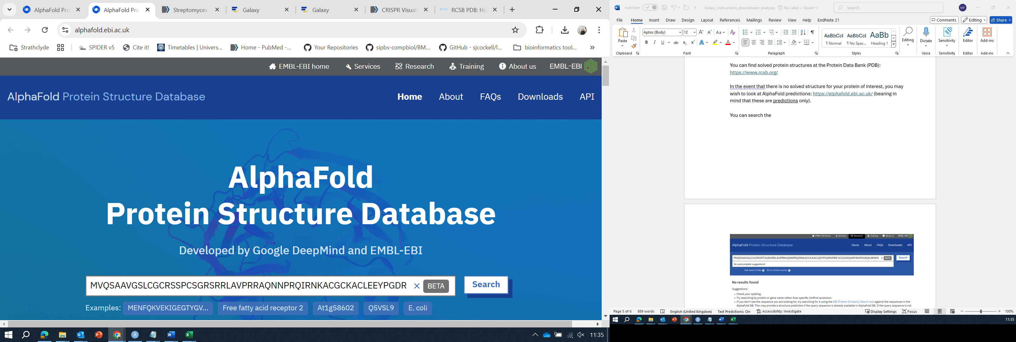

Figure 8. Alphafold database search for a protein sequence of interest.

In this case, the top hit (Figure 9) is a tyrosine-type recombinase/integrase from a *Kitasatospora*, which shares 73% identity with my query sequence. (Why would this protein be encoded in a *Kitasatospora* genome?)

Clicking on the hit takes you to a page with the predicted structure and further information (Figure 10).

Note that there is an online tutorial (<https://www.ebi.ac.uk/training/online/courses/alphafold/>) for help with AlphaFold and an extensive FAQ section for help.

Note also that there is a Colab notebook which can be used to predict the structures of proteins that are not in the database (<https://colab.research.google.com/github/deepmind/alphafold/blob/main/notebooks/AlphaFold.ipynb>)

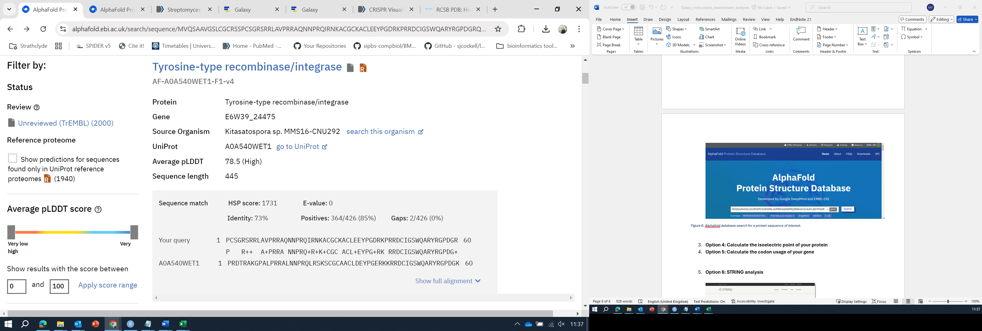

Figure 9. Top hit in AlphaFold from my search query.

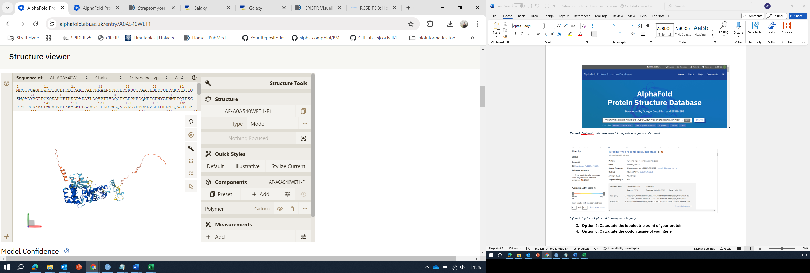

Figure 10. Predicted structure of the top AlphaFold hit.

Further analyses (relating the structure to your MSA/phylogenetic tree, identifying residues of particular interest, potential protein/protein interactions, etc. will vary depending on your particular project and research question of interest.

1. **Option 3: Calculate the physicochemical properties of your protein**

Depending on your project, you may be interested in having a closer look at various properties of your protein (e.g., the isoelectric point or the amino acid composition.)

You may find the Expasy tool ProtParam (<https://web.expasy.org/protparam/>) useful for this – you can provide a protein accession (UniProt KB ID) or an amino acid sequence (Figure 11) and ProtParam will calculate the number of amino acids, molecular weight, theoretical isoelectric point (pI), amino acid composition, etc. for you (Figure 12). The documentation - <https://web.expasy.org/protparam/protparam-doc.html> - explains these calculations in more detail.

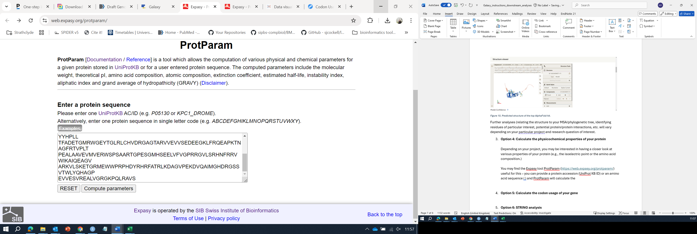

Figure 11. Using ProtParam with an amino acid sequence query.

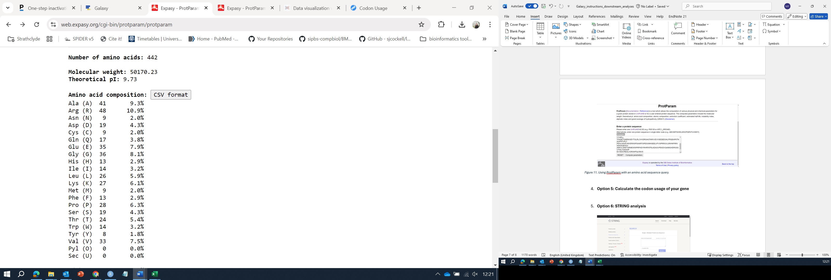

Figure 12. ProtParam output results.

Be sure to save your results in an appropriate format for any downstream analyses.

1. **Option 4: Calculate the codon usage of your gene**

Note that for this, you will need the nucleotide sequence of your coding sequence, NOT the amino acid sequence (make sure you understand why this is…). Just as a reminder, you can obtain this by running the “Extract sequences from GenBank” on the GenBank file you got from pharokka (or any other annotation tool) – making sure to specify that you want to extract CDS and that the output type should be nucleotides.

You may want to look at the codon usage of one or more genes.

There are many different tools which can be used to do this; one of these is the Codon Usage tool from the Bioinformatics Sequence Manipulation Suite: <https://www.bioinformatics.org/sms2/codon_usage.html>

In this example, I have copied the entire output from my “Extract sequences from GenBank” results, which is the nucleotide sequences for all of the annotated coding sequences in my phage genome (Figure 13). Note that I have specified that the program should use the the bacterial genetic code.

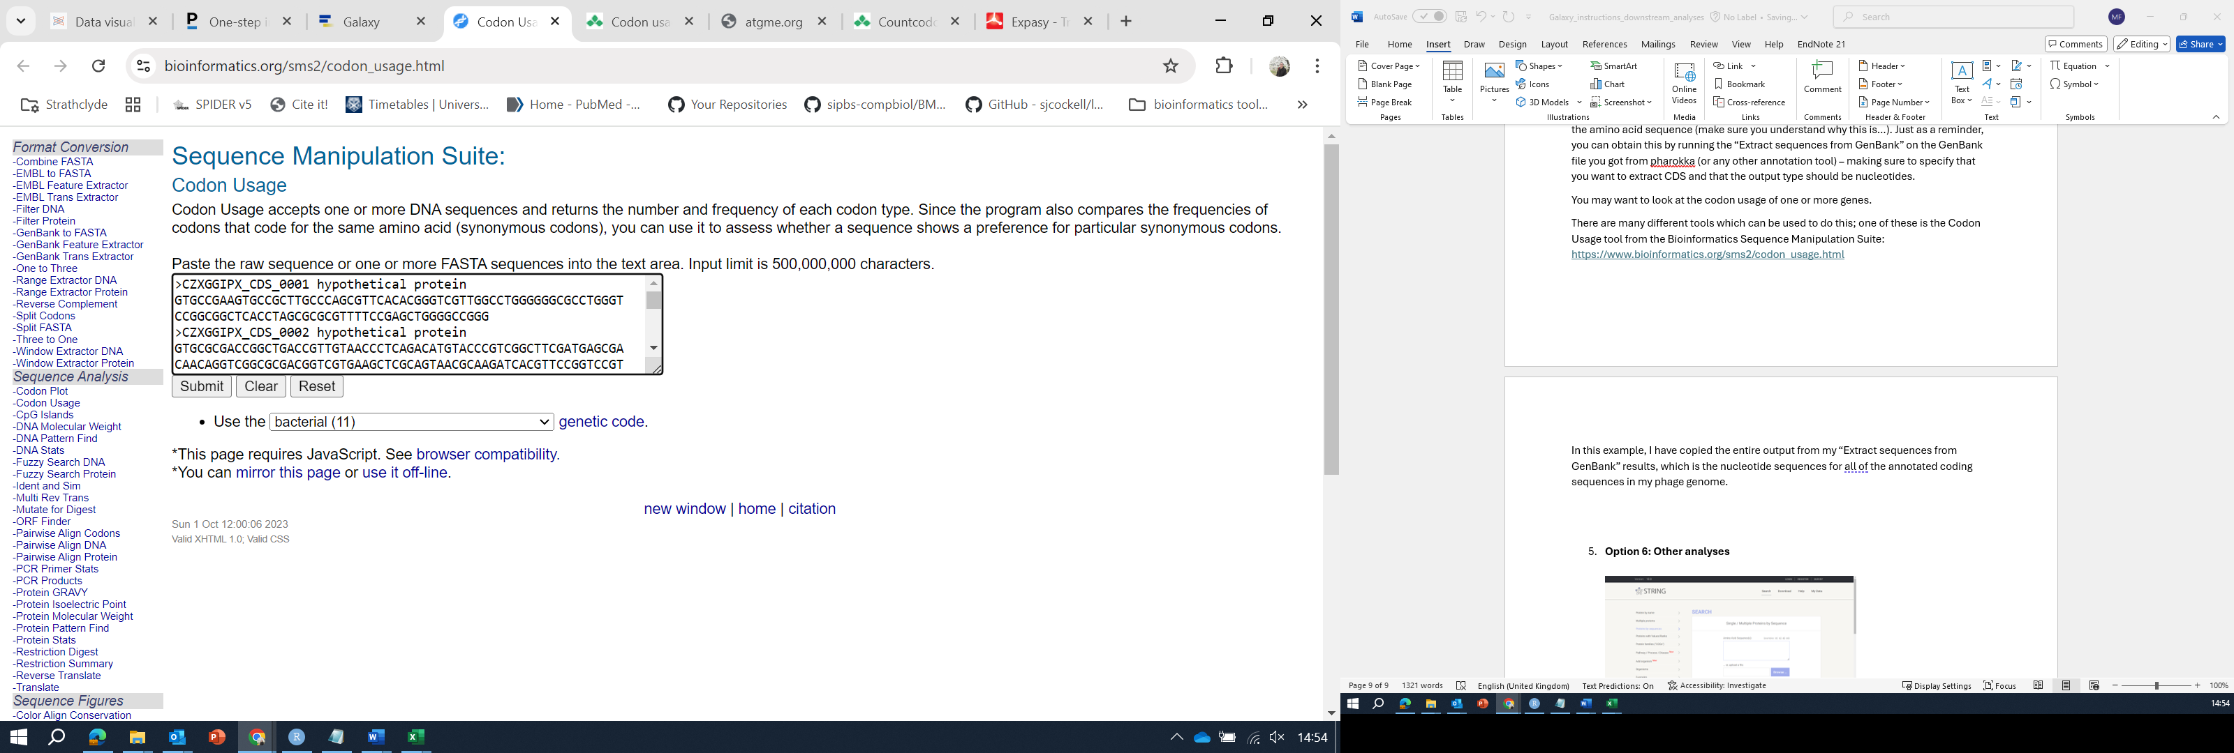

Figure 13. Using the Codon Usage tool.

When I click “submit” a popup window appears which has the Codon Usage for each of the coding sequences I submitted (Figure 14).

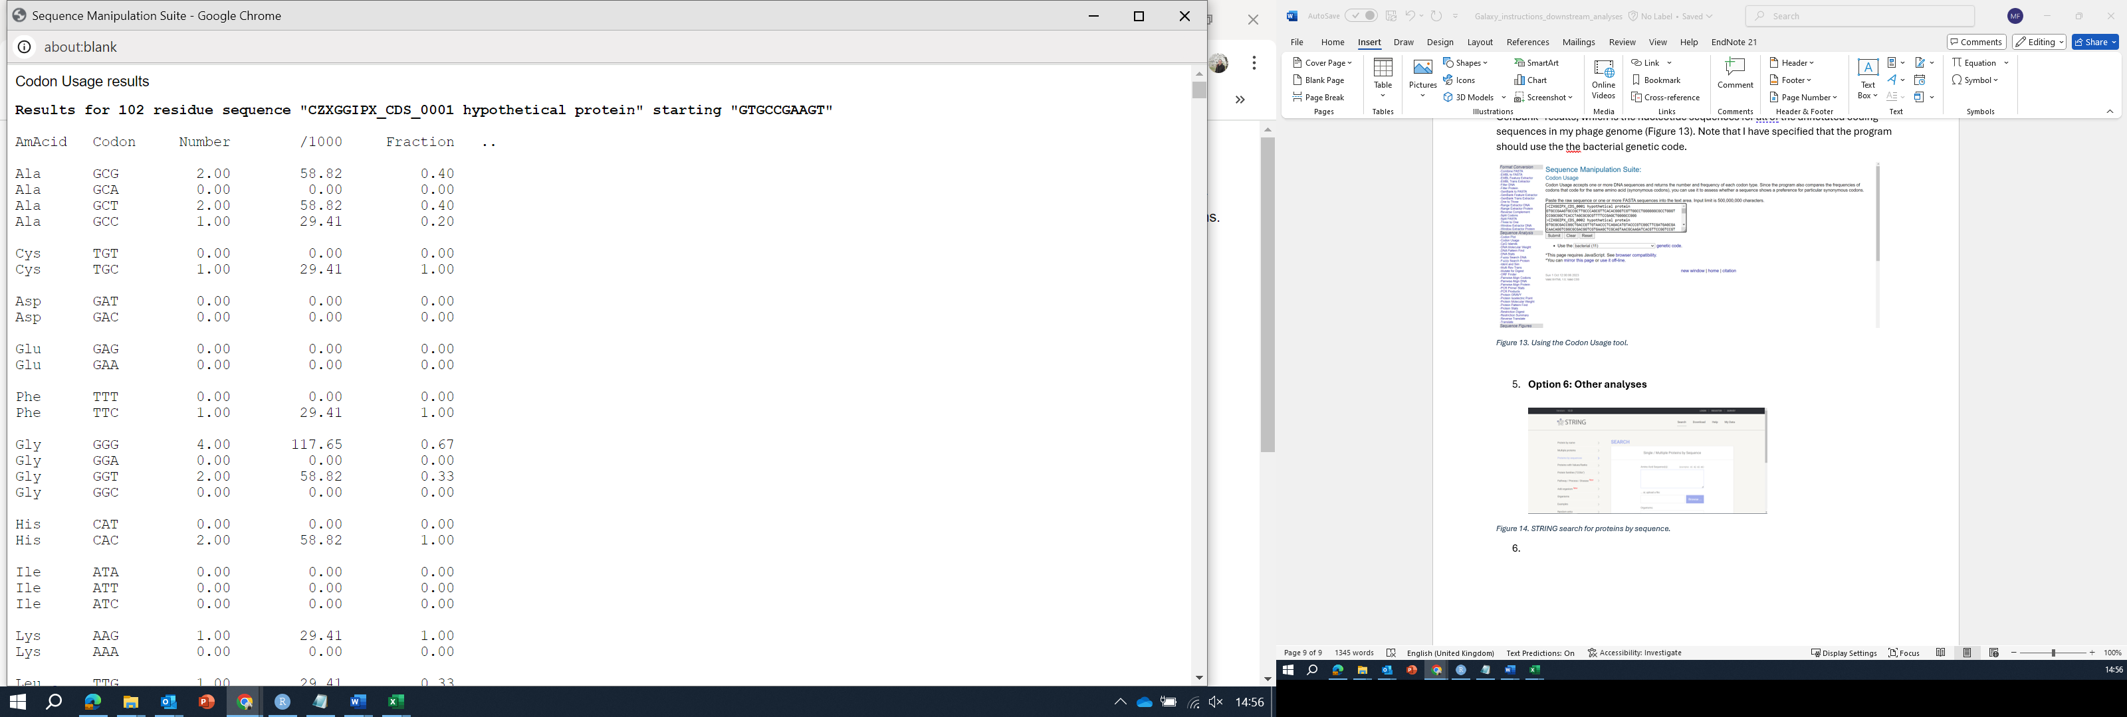

Figure 14. Codon usage results.

This is tab-separated data, so if you wish to save it (for future reference and/or other analyses), you should save it as a .tsv file.

To do this, copy and paste the results for your coding sequence into a Notepad file, or the equivalent program in Mac/Linux/etc. (Make sure you copy the entire thing!)

Save the file by selecting “Save As” and then enter the file name (e.g. CZWGGIPX_002**.tsv** in this example. Make sure you specify to “Save as type:” **All Files** (otherwise the default is a .txt file, which will make any downstream work much more difficult/impossible). Then click “Save” (Figure 15).

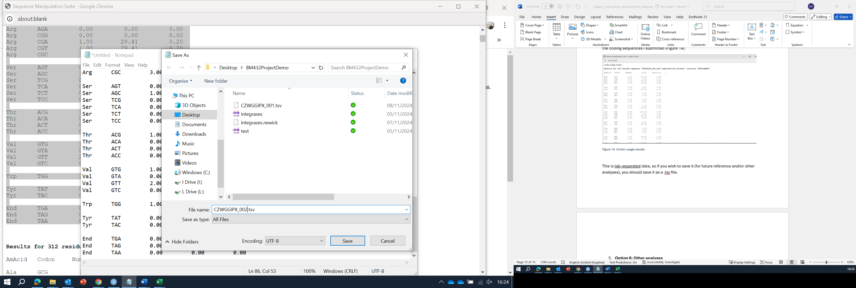

Figure 15. Saving codon usage results as a .tsv file

If your sequence of interest appears to have any particularly rare codons – or if you are generally interested in the use of rare codons – you may also find it useful to use ATGme (<http://atgme.org/>) to visualise codon usage across your sequence.

To do this you will need to provide ATGme with your sequence of interest and a codon usage table. You can get the codon usage table from <http://www.kazusa.or.jp/codon/> (as indicated on ATGme) – probably most sensible to use the codon usage table for *S. coelicolor* ().

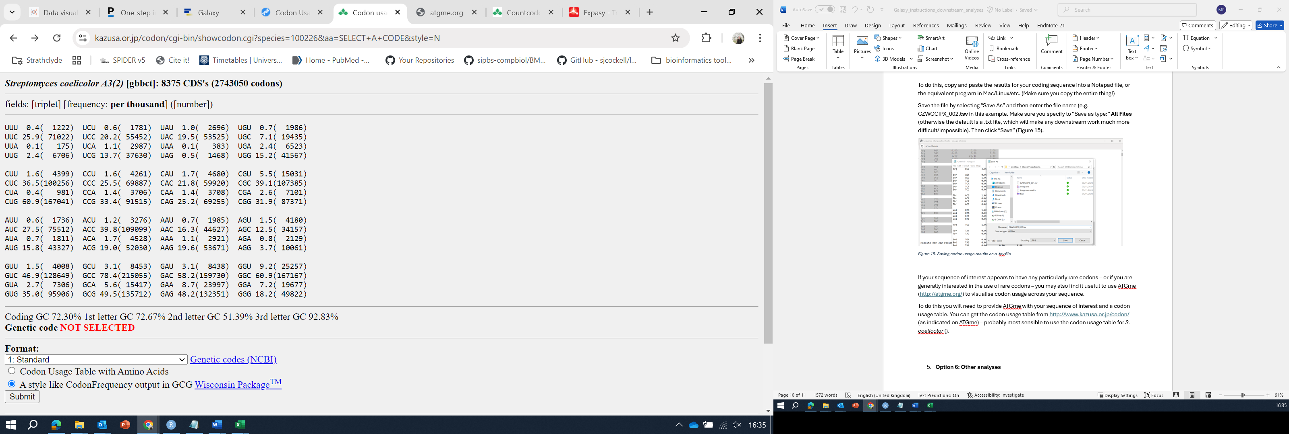

Figure 16. Streptomyces coelicolor A3(2) codon usage table.

Copy and paste your query sequence (nucleotides) where indicated, and copy and paste the codon usage table where indicated (Figure 17, and then click “Start processing”.

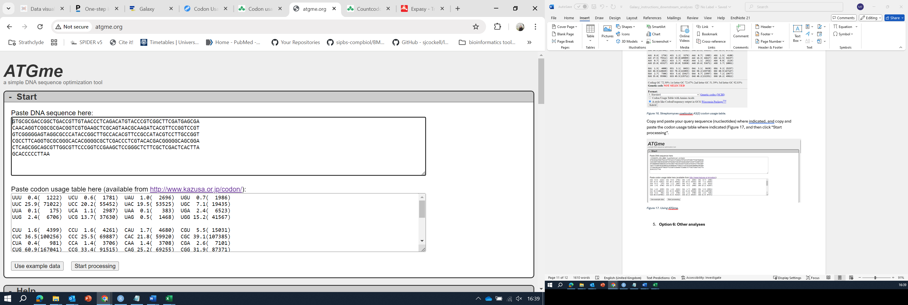

Figure 17. Using ATGme.

The results (Figure 18) will highlight rare codons in orange and very rare codons in red (Click the + next to “Usage data” to expand).

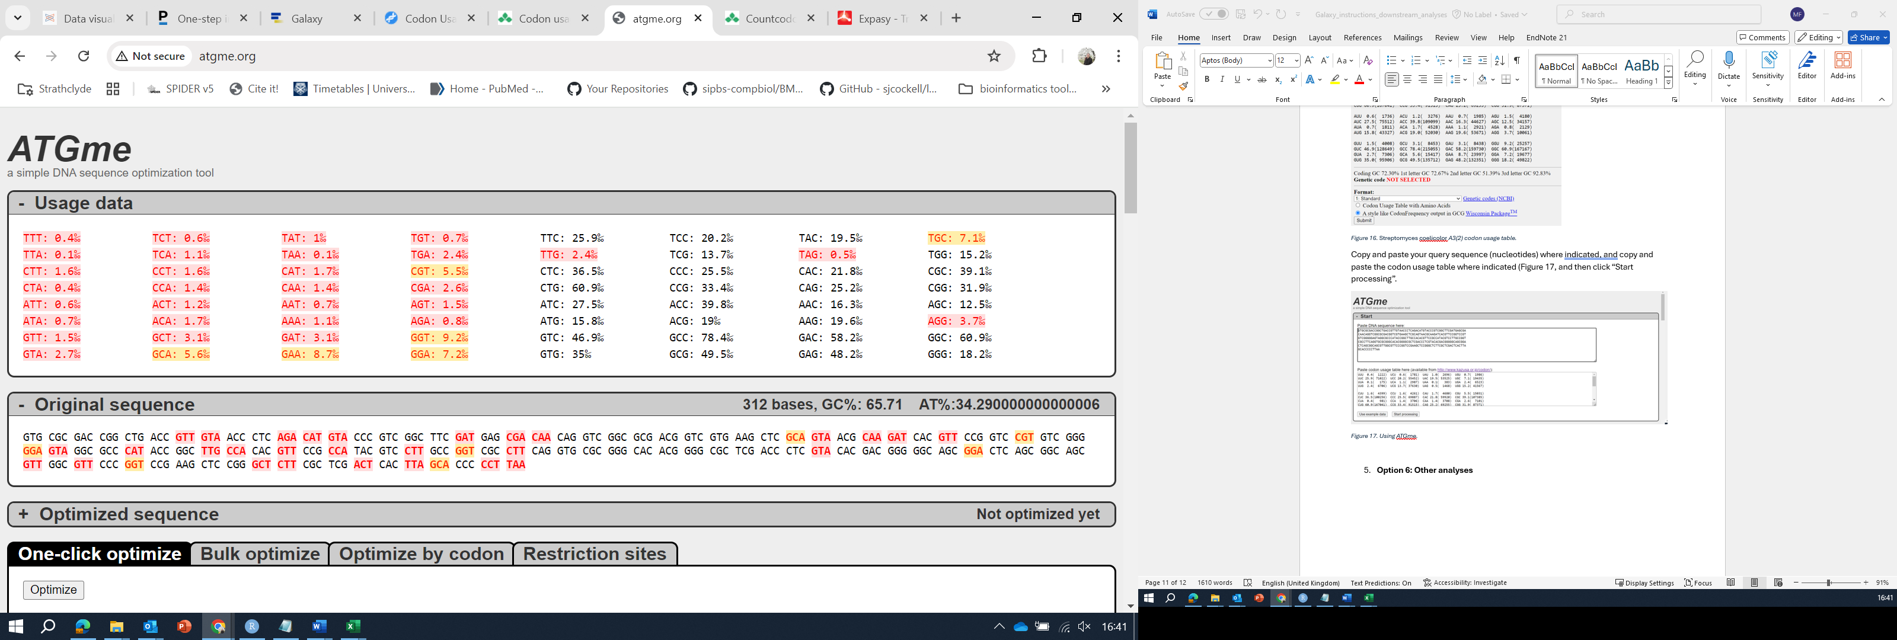

Figure 18. ATGme results.

1. **Option 5: Database searches**

Depending on your gene protein/project aims, you may also find it useful to search for your sequence of interest in some of the many biological sequence databases that are available, e.g.

STRING: <https://string-db.org/>

UniProt: <https://www.uniprot.org/>

NCBI (Gene or Protein): <https://www.ncbi.nlm.nih.gov/>

Microbesonline (for bacterial genes): <https://microbesonline.org/>